34.28: a) Given
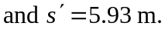
b) The image is inverted since both the image and object are real 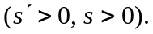
c) 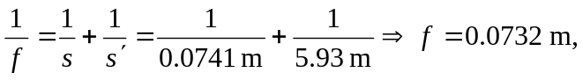and the lens is converging.

